**THE LIBERATION OF THE BERGEN-BELSEN CONCENTRATION CAMP.**

Eighty years ago, on April 15th 1945, a small detachment of the British Army’s 11th Armoured Division arrived, following an agreed truce with the Germans, at the Bergen-Belsen Concentration near the North German town of Celle. What they found, to borrow the title of Sam Mendes’ excellent documentary shown last week on BBC Television, defied belief.

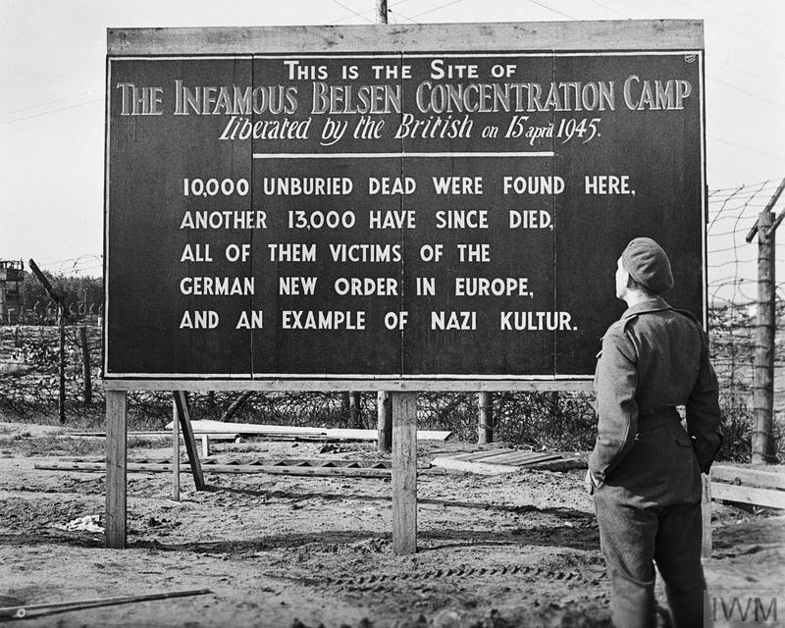

Belsen, as it came to be known, was a charnel house of the dead and dying.

The original liberators, 11th. Armoured Division, were needed elsewhere and an urgent call went out for substantial re-enforcements and a large force from the 113th Anti-Aircraft Division of the Royal Artillery, including a substantial number of soldiers from the 5th Battalion of the Durham Light Infantry, raced 238 miles to Belsen, arriving on April 18th.

Their tasks included the burial of the dead, the care of the dying and the saving of the lives of those who could be saved. A huge task force of medical personnel, doctors and nurses, arrived soon after and began to tackle their gruesome responsibilities. Disease was rampant; typhus, TB and dysentery. Starvation had already taken many additional lives. It was a race against time to save as many lives as possible.

The burial of the dead was carried out, under the supervision of the British soldiers, by the captured SS guards. Amongst these were the Commandant, Joseph Kramer and the evil SS Guard Irma Grese whose favourite hobby seemed to be firing pot shots at prisoners. These two were amongst eleven SS personnel hanged for war crimes in December 1945.

Belsen was not an extermination camp, although tens of thousands did die there, some murdered with their corpses burned in ovens. There was a substantial Jewish population, many of whom had been force marched from the death camps of Poland; Auschwitz, Sobibor, Majdanek and others, when the Russians were closing in at the end of 1944. Anne Frank was perhaps the best known of the Belsen victims.

The world first heard of Belsen from the BBC when Richard Dimbleby reported from the camp in a landmark broadcast on April 19th 1945. Had any UK citizens ever questioned why they had been asked to go war with Germany, here was their answer. The British soldiers rounded up the local population and forced them to visit the camp. Many locals claimed they had no idea of what was going on at the camp. At about the same time, US forces liberated Buchenwald camp near Weimar. This was filmed by the legendary Hollywood director Billy Wilder (Some Like it Hot) and the entire local adult population was forced to attend one the many screenings in cinemas.

My book ***LIBERATING BELSEN*** Remembering the soldiers of the DURHAM LIGHTINFANTRY is a brief resume of the events of April and May 1945 and incudes extracts from Richard Dimbleby’s broadcast as well as transcripts of audio recollections of the soldiers recorded by the Imperial War Museum . It can be bought from Sacristy Press (PO Box 612 Durham DH1 9HT – [www.sacristy.co.uk](http://www.sacristy.co.uk)) or ordered from bookshops. The book is also available on eBook platforms.

