**THE BATTLE OF THE BULGE**

December 1944 – January 1945

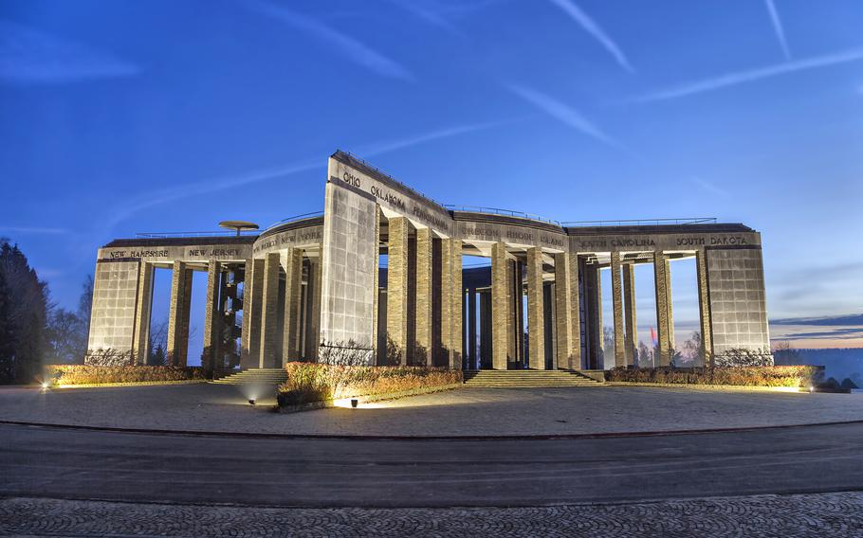

*The Battle of the Bulge Memorial at Bastogne in Belgium*

The Ardennes offensive, now known as The Battle of the Bulge, was one of the bitterest campaigns of the closing months of the Second World War. US and other Allied troops faced a surprise German attack through the Ardennes forest, the densely wooded area principally in Belgium and Luxembourg , repeating their devastating incursion into the same area in the late spring of 1940. The Allied troops were resting in the area, following six months of relentless action following D Day.

The Germans, on the retreat from the Allies in the West and the Soviet Union in the East, mounted a last desperate campaign to reverse their fortunes. Their chief objectives were to attack and defeat each of four Allied armies one by one before capturing the deep water port of Antwerp, thereby devastatingly affecting vital supply lines.

The offensive began on December 16th 1944 and, initially, everything went the Germans’ way and was in their favour. The Allied troops were exhausted, the element of surprise complete and even the weather was on their side, low cloud keeping the vastly superior Allied air forces on the ground. Air reconnaissance was impossible . By December 20th, the Germans were threatening the Belgian city of Bastogne, strategically vital because it controlled access to roads leading to Antwerp. The Germans heavily outnumbered the Allies who had a small number of armoured units and US troops from the legendary 101st Airborne defending the city.

The defenders fought courageously for six days in the most foul conditions; bitter winds, snow, ice and sub zero temperatures before being relieved by armoured units of Patton’s Third US Army. Although the campaign dragged on until the end of January, it effectively ended with the raising of the siege of Bastogne.

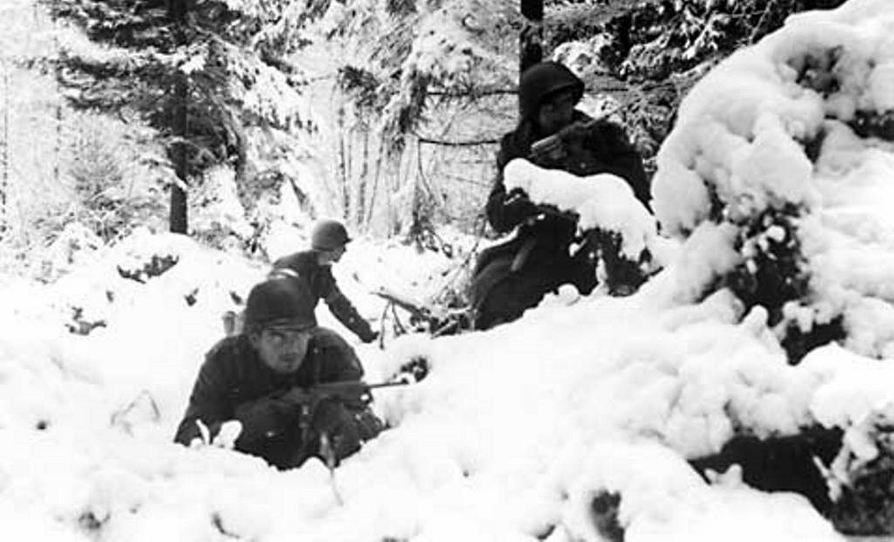

The Battle of the Bulge was the toughest campaign fought by US troops during the European War. Eight thousand were killed to go alongside ten thousand Germans and three thousand non-combatants. The Germans committed war crimes, including the murder of eighty four US soldiers by members of the Waffen SS who were later tracked down and tried at Dachau. Seventy three former SS members were found guilty of what became known as the Malmedy Massacre. Forty three death sentences were later commuted to long spells in prison.

The Battle of the Bulge is remembered in word and film. Antony Beevor’s book *Ardennes* *1944* is a superb recounting of the campaign while I remember with fondness Ken Annakin’s 1965 film *The Battle of the Bulge* which starred Henry Fonda (amongst others!). More recently the world has been treated to the Steven Spielberg/Tom Hanks inspired *Band of* *Brothers*, a superlative television series which followed the fortunes of Easy Company of the 101st Airborne. Episode Six tells of the Siege of Bastogne.

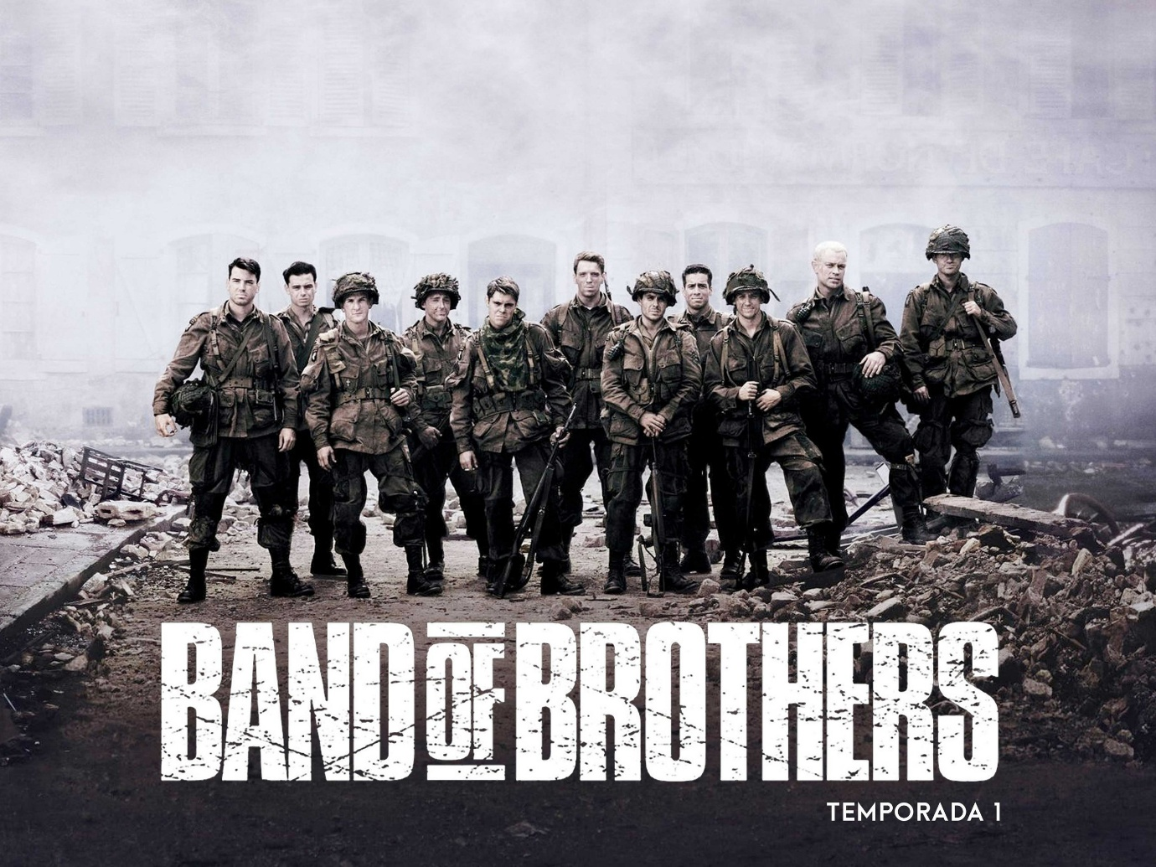

NEXT MONTH

I’ll be remembering the soldiers who had the ghastly task of liberating the German Concentration Camp of Belsen. The post will be up in the middle of the month at about the time thoughts will be turning to the 80th. Anniversary of the event.